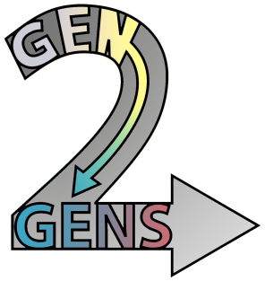
Generation to Generations
Service Award Form

Student contact info- Phone: ( ) Email:
Total number of hours spent visiting your Grandfriend: ________ Number of visits:_____
Signature of nursing home Activities Director (or other administrator):_____________________
Log of each visit:
Date of Visit | Time of Visit | Activity Completed
To be submitted with Grandfriends Project submission to the GEN2GENS team (Benjamin Franklin High School: Jane Maher, Room 233), Fall 2012
Detailed instructions at www.gen2gens.org Grandfriends Project

